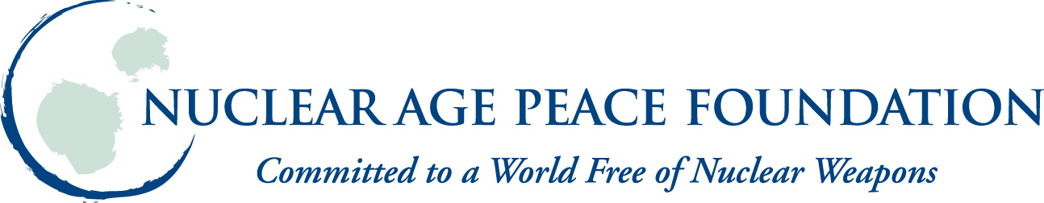 BAN ALL NUKES GENERATION

Exchange of views on progress of the May Session and outlook towards the summer sessions

Intervention

Delivered by Christian N. Ciobanu, Nuclear Age Peace Foundation and Ban All Nukes Generation

25 May 2013

The Opened-ended Working Group (OEWG) is significant because it provides a forum for states, both members of the Conference on Disarmament (CD) and non-members of the CD to have honest and frank discussions on how to move forward on nuclear disarmament.

For too long, the discussions on nuclear disarmament have been at a deadlock, especially in the current bodies of the international disarmament machinery.

We, as civil society and the youth, have often been relegated to the margins of the international disarmament machinery. We welcome the open and democratic forum of the OEWG meetings so far and urge all members to promote the participation of civil society in future meetings.

The OEWG provides an ideal forum for all actors to send a clear and direct message that the international community cannot simply wait for the Nuclear Weapon States to eventually disarm their nuclear weapons. These states are continuously modernizing their nuclear arsenals, facilities of the nuclear industrial complexes, and maintaining their nuclear weapons on high alert as in the case of the states with the largest arsenals of nuclear weapons.

The Nuclear Weapon States are simply ignoring the international community`s calls for them to fulfill their Article VI obligations, legally binding multilateral nuclear disarmament obligation. We urge these states to fulfill their duty to act in good faith in regard to nuclear disarmament. This stems from three sources: International law, of which good faith is a central principle; Treaty obligations solemnly undertaken, as for example in the Nuclear Non-Proliferation Treaty and the Protocol to the Geneva Convention of 12 August 1949; and the duties imposed by the International Court of Justice.

Although we urge these states to fulfill their duty to act in good faith, we cannot continue to wait for them to catch up to their commitments while they subscribe to an inherently discriminatory approach in which they are ignoring the conditions set forth in the indefinite extension of the Nuclear Non-Proliferation Treaty.

The Nuclear Weapon States have let pass the opportunity to make good on their promises and to demonstrate their good faith. In such a situation, the Non-Nuclear Weapon States must rise to their responsibility to do anything and everything they can to maximize the pressure on the possessors of nuclear weapons.

As we move forward to the summer session, it is vital that the groups, such as the African Group, Arab Group, Eastern Group, Latin American and Caribbean Group, League of Arab States, New Agenda Coalition, Non-Aligned Movement, Western European and Others Group prepare and circulate key working papers in the next sessions.

As a starting point, the groups could respond to the different approaches to nuclear disarmament, and the discussions generated from the panels from the first segment of the OEWG.

The added value for these working papers would be that they would enable states, which did not attend the first segment of the OEWG, to provide useful input to the subsequent discussions in the OEWG. It would further enable the OEWG to bring all angles and aspects of nuclear disarmament to the table in order for states to move forward with proposals at subsequent periods.

We look forward to the next segments of the OEWG and we wholeheartedly applaud the OEWG. The OEWG is a good opportunity for us to truly move forward on nuclear disarmament to establish a world that is free of nuclear weapons.

